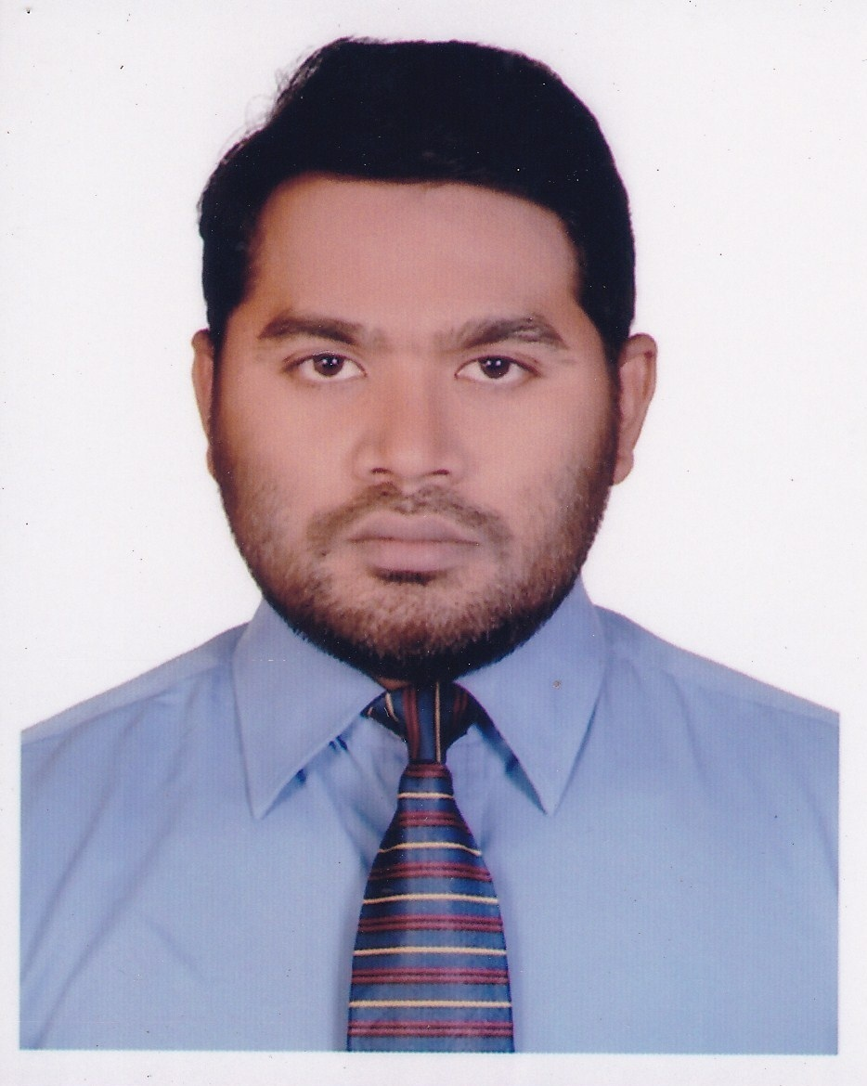
CURRICULUM VITAE
OF
ANWARUL KARIM

Career Objective:
To run responsible position where I can be use my technical and interpersonal skills, creativity and all of my learning experiences in order to develop my career as well as to contribute in the welfare of the organization. Committed and motivated Commercial /supply chain Management. Exceptional and quick decision making skills strong work ethics, professional demeanor and great initiative, proficient and quickly learning new procedures and taking ownership of diverse project.

Contact Address:
Anwarul Karim (Anwar)
House # 01, Lane # 11, Al-Amin Road,
Konapara, Word # 65, Demra, Dhaka
Mob: 01552-479550, 01911-161885

Experience:
Company Name: MITSUBISHI ELECTRIC ELEVATOR AND ESCALATOR
Department Name: AG MELCO Elevator Company BD Ltd.
Position: Sr. Executive, (Commercial).
As a commercial executive I provide support to the management team within a company sales department and accounts department. Preparation the Proforma Invoice & send to the client. L/C checking & send reply regarding the LC correction & amendment issue to client. Closely monitoring & if required then talking with client & Bank over phone for solution purpose regarding the LC correction & amendment issue. Production schedule monitoring & update to Sales Engineers, Accounts Department & FOD. Follow up the projects shipment from factory as per L/C. Follow up with H.O. regarding the submissions of commercial shipping document in bank timely. Coordinating with C&F agent regarding customs assessment & customs duty for clearing the materials from port to project site. Coordinate with Field department regarding the project site ready before clearing the consignment from customs. Pending shipping documents follow-up with H.O. Coordinating with client & follow up for storing the elevators materials safely in site. Checking the C&F agent’s bill & process the bill to Accounts department. After delivery the elevator materials, send the original Bill of Entry to Client & Bank. Responsible for prepare the Proforma Invoice for spare parts & open the LC. Responsible for send the Shipping Instruction for shipment the material (spare parts or TR material) by Courier, Air-freight & the LCL delivery. Send the request for Air freight approval to H.O. Checking the Shipping documents as per LC. Regularly contact with shipping line agent for checking the container status.
Work Duration: June - 2019and Current.
Address: 191/1 Regnum Center, Tejgaoan Gulshan Link Road, Tejgaoan I/A, Dhaka-1212.
Company Name: RANGPUR FOUNDRY LTD. - RFL
Department Name: Bangladesh Lift Industries Ltd (Property Lift)
Position: Assistant Manager (Supply Chain Management-Import).
As a SCM manager I provide support to the management team within a company sales department and operation department.
Negotiate and collect better prices from supplier. Keep record and maintain a database for order value with details specification. Keep record and maintain a database for shipment schedule. Collect PI and calculate with weight and make final PI. Collect LC open related all approval and make costing. Prepare L/C requests to bank for new sales and spare parts requirement. Coordinate with client for L/c's if the L/C is in scope of client. Check the terms and conditions of client LC's and ensure company's interests are protected. Negotiate better prices with C&F agents to reduce forwarding related expenses. Collect approval from management and Collect documents from bank. Coordinate with C&F agent during material delivery and follow up. Prepare and circular weekly shipment status. Sending requests to suppliers for special equipment / catalogues /samples & follow up. Track and update dues report with suppliers for H.O reports and presentations.

Work Duration: May-2014 and June-2019.
Address: PRAN-RFL Center, GA-105/1,Pragati Saroni, Middle Badda, Dhaka-1212.

Educational Qualification:
M.S.S (Masters) in Economics – 2007 (Result published on -2010)
University: Jagannath University, Dhaka.
- Placed in the First Class.

B.S.S (Hon’s 4 years.) in Economics – 2006 (Result published on -2008)
University: Jagannath University, Dhaka.
- Placed in the Second Class.

Higher Secondary Certificate - 2002
Name of the Institute: Tamirul Millat Kamil Madrasah, Dhaka.
Group: General Group.
Board: Bangladesh Madrasah Education Board, Dhaka.
• Placed in the Second division.

Secondary School Certificate - 2000
Name of the Institute: Dogair Daruchunnat Alim Madrasah, Demra, Dhaka.
Group: General Group.
Board: Bangladesh Madrasah Education Board, Dhaka.
• Placed in the First division.

Personal Information :
Father’s Name : Late Hatem Ali.
Mother’s Name : Hafiza Khatun.
Date of Birth : 01st March, 1986.
Religion : Islam.
Home District : Munsigonj.
Nationality : Bangladeshi by Birth.
Marital Status : Married.
E-mail Address : anwar.bd1386@gmail.com
National I.D Card No : 6898893174
Language Proficiency : Bengali & English.

Computer Knowledge :
Operating System : Windows XP, Windows 2000 and Windows 2007.
Hardware : Computer assembly, Software installing and troubleshooting.
Application Program : MS Word, MS Excel, MS Power, MS Access, Internet and Email.
Organized by : NECTA COMPUTER EDUCATION
86, Shahid Faruq Road, South Jatrabari, Dhaka-1204.
Professional Experience :
- Strong Interpersonal communication & management skills.
- Leadership and ability to work independently.
- Excellent written and verbal communication skills.
- Proven experience in customer and market research.
- Have a good connection with customers and proper channels.
- Organized self-motivated and service minded.
- Excellent problem solving skills.
- Pleasant personality and can do attitude.
- Good knowledge & skills in working with MS Word, MS Excel, Power Point.
- Using Internet and Emails correspondence.

Specialty :
♦ Communicative and Friendly.
♦ Determinant and sincere to work
♦ Ability to work in group as well as individually.
♦ Creative and innovative
♦ Working capability under stress

References :
a) Quamruz Zaman.
Chief of Maintenance Engineer
Thyssenkrupp elevator (BD) Pvt. ltd.
Anchor Tower, (7th floor), 108, Bir Uttam CR Dutta Road, Dhaka 1205.
Contact- 01777-78 52 70..

b) Md. Zakir Hossan.
Assistant Programmer,
Ministry of Public Administration,
Bangladesh Secretariat, Dhaka - 1000
Contact Number- 01712-241165

Signature


Date: -20/10/2019
Anwarul Karim

